ANNA OCH NILS HÅKANSSONS STIFTELSE

The purpose of the foundation is to promote scientific education and research, thereby supporting the country’s forestry.
Your information

Name applicant | Telephone number
Organisation number/personal identification number | Email address
Name contact person / supervisor (if applicable) | Telephone number / e-mail contact person
Postal address (applicant)

ZIP/Postal code | City
Bank name | Bank account number including clearing number

Background
Provide a brief background and description of your project.

Project description
Here you describe your project. Explain what goals you have with the project and what expected development you have? Describe the activities you intend to carry out. If there is a project plan, attach it to your application.

Time period for the project

Enter the start date for the project Enter expected end date for the project

Sustainability work

It is important to us that the foundation makes contributions to projects that contribute to the global goals of Agenda 2030.

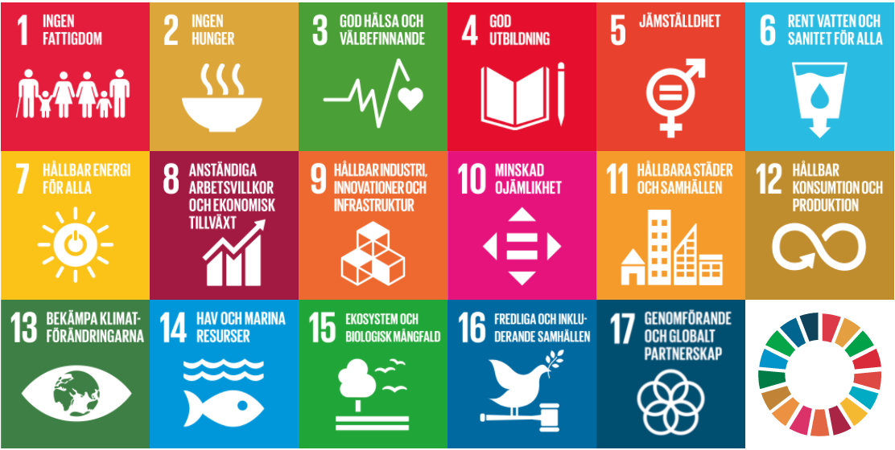
https://www.globalamalen.se/om-globala-malen/

Please describe how your particular project contributes to one or more goals.

Costs and financing

What costs do you have in the project?
Enter which costs you have and divide them into cost categories if as applicable. If you are able to recover the VAT, it does not constitute a cost and the VAT part is not eligible for a grant. If the VAT constitutes an actual cost, it is, on the other hand, eligible for contribution. In that case, please enter the cost including VAT.

Cost Type Amount
Personnel costs
Material costs
External services
Other costs
Total costs:

Financing

Enter all intended financiers in the project. State whether the financing has been applied for or already granted.

Amount Requested Granted
Applied from Håkansson's foundation
Own contribution

Other financiers Amount Requested Granted
Total project financing:

Appendices

Please attach the following attachments to your application:
- Project plan
- Other documents that supplement your application (such as CV, references etc.)

(GDPR)
When you submit information containing information that can identify you as an individual, you have provided us with your personal data. You hereby consent to us using the data to handle your case. The data is not used for any other purpose and is handled solely by the foundation.

Place Date

……………………. ………………………………..

………………………….. …………………………………………
Signature Name clarification

………………………….. …………………………………………
Signature Name clarification

Approval by institution or supervisor

Place Date

………………………….. …………………………….

………………………….. ……………………………
Signature Name clarification

Send your application; digitally signed or signed by wet ink to:

info@annaochnilshakanssonsstiftelse.se

